Physics-Informed Neural Network Hybrid with LSTM and Lagged Steps for Real-Time Harmonic Distortion Prediction in Smart Grids
Mahmoud Mohammadnezhad Kiasari; Hamed H. Aly, SMIEEE
Smart Grid and Green Power Research Laboratory
Electrical and Computer Engineering Department, Dalhousie University

Abstract— Real-time prediction of total harmonic distortion (THD) is essential to ensure power quality in smart distribution grids, but the current methods have difficulties balancing accuracy with computational efficiency and physical consistency. This work proposes hybrid architecture of combined Long Short-Term Memory networks (LSTM) and Physics-Informed Neural Networks (PINN) which incorporate harmonic-domain constraints directly into the loss function. The model applies three physical principles: THD identity preservation, harmonic balance among frequency components, and consistency of power quality, whereby the predictions are required to meet the laws of electrical engineering and take advantage of sequential pattern recognition. We validate the Hybrid PINN-LSTM on two independent validation datasets from 10 years: United Kingdom residential feeders (2011-2012, 105,120 samples, measurements obtained with Fast Fourier Transform) and Russia smart grid networks (2021, 297,943 samples, measurements obtained directly from three-phase harmonics). Extensive simulations on seven models show the Hybrid PINN-LSTM achieves average mean absolute error of 2.29% and root mean square error of 3.32, which is 16.7 and 15.7% lower than the best baseline (Temporal Convolutional Network). These improvements are statistically significant (p<0.01). Ablation studies uncover physics constraints improve 27.5% over standalone LSTM. The model has sub-10 millisecond inference latency, which allows the model to be deployed in real-time on edge devices. Consistent performance across fundamentally different measurement methodologies demonstrates true generalizability for operational smart grid deployment.
Keywords—PINN, LSTM, THD, Smart Grids, Real-Time Prediction

Introduction
The transition from fossil fuels to renewable energy systems has significantly reshaped the dynamics of modern power grids. However, the penetration of these energies and the use of electrical devices, mostly for different types of energy conversion and nonlinear loads, have led to the grid being exposed to more Total Harmonic Distortion (THD), which has raised concerns among engineers, as it could endanger the stability of the grid [1]. Excessive THD, current, or voltage can lead to increased power loss, equipment malfunction, and grid instability. Based on this, an accurate THD prediction can ensure that real-time power system management can handle it appropriately [2]. Real-time THD monitoring can enhance power grid management by enabling the early detection of quality issues, preventing equipment damage, and facilitating proactive control. Continuous analysis helps optimize stability and costs, which is vital for the unpredictability of renewable energy sources. Several studies have explored advanced techniques for predicting THD. For instance, a study [3] focused on an enhanced machine learning method to reduce the THD in cascaded H-bridge multilevel inverters (MLIs). In addition, this study [4] investigated the integration of photovoltaic (PV) systems into smart grids and highlighted their impact on THD.
Traditional methods, such as Fourier analysis and frequency-domain simulation[5], are effective for static grid configurations; however, they struggle to adapt to the dynamic and stochastic nature of modern power grids. Machine learning techniques have recently gained attention for addressing this gap because their ability to model nonlinear relationships and temporal dependencies in power systems is sufficient to overcome these obstacles. However, previous studies have often fallen short in addressing critical areas. For instance, this paper [6], while effectively utilizing deep learning techniques for forecasting harmonics in hybrid renewable energy systems, does not leverage domain-specific physical constraints that can improve predictive accuracy and robustness in dynamic grid environments. Furthermore, this study overlooks the critical temporal dependencies introduced by rapid fluctuations in renewable energy generation and nonlinear load behavior. Another study [7] integrated Physics-Informed Neural Networks (PINNs) for electricity load forecasting by incorporating domain-specific physics laws. However, it lacks explicit modelling of temporal dependencies, which are vital for accurate predictions in a dynamic grid environment. Finally, this study [8] used a hybrid model of Long Short-Term Memory (LSTM)–PINN [4] [9] for lithium-ion battery temperature prediction. Although it demonstrated improvements in accuracy compared to sole models, its computational complexity poses challenges in terms of scalability and real-time application.
Although PINNs ensure physical consistency, capturing temporal dynamics remains a challenge, whereas LSTMs handle sequence dependencies but lack the physical constraints. Therefore, the individual utilization of these techniques for THD prediction is limited to a certain extent. However, their integration with dynamic grids remains largely unexplored, creating key areas for future research. This study to address the limitations of using PINN to integrate the physical laws governing harmonic behavior with LSTM networks, which model temporal dependencies to enhance the prediction of harmonic distortion. In this study, lagged steps[10] were incorporated to capture the temporal dependencies arising from rapid fluctuations in renewable energy generation and nonlinear load behavior. Implementing this method enables effective deployment in complex power systems and improves its practicality for managing nonlinear and dynamic loads. Moreover, to reduce model complexity and computational cost, a Genetic Algorithm was employed based on [11].
Although LSTM-PINN hybrids have been previously studied in other areas (including battery temperature estimation and load forecasting), this study is the first to implement an LSTM-PINN model for THD prediction in power transformers. In contrast to previous studies, this physics-aware loss injects harmonic-domain equations directly into the loss, such as the THD identity, harmonic balance, and power quality consistency, while incorporating time-dependencies via lagged inputs. The resulting distinct integration allows for physics-conformable, accurate, and real-time THD projection under dynamic grid conditions, thereby filling an important gap in the literature.
This paper presents four concrete contributions to the real-time power quality forecasting. First, it proposes the first hybrid LSTM-PINN framework dedicated for THD prediction, in which temporal dependencies are learned from the data while physical laws in the harmonic domain are explicitly imposed in the training process. Second, the model incorporates THD-specific physics constraints, such as the THD identity, harmonic balance and power quality consistency relations, directly into the loss function, which prevents making physically infeasible predictions and reduces spurious predictions. Third, the study proposes a lagged temporal feature construction based on GA feature selection, and systematically determines an optimal length of lag (15 time steps) that is consistent with harmonic dynamics in residential distribution networks. Finally, computational efficiency of the proposed framework is demonstrated which is suitable for mobile deployment and has sub-10 ms inference latency, along with consistent performance improvement over standalone LSTM and PINN baselines in terms of MAE and RMSE on high-resolution smart-grid power quality data.

Integrating machine learning methods
In this section, the proposed hybrid LSTM-PINN model for real-time THD forecasting is described in detail. The method combines a data-driven temporal learner (LSTM) with a physics-informed loss, in which the harmonic-domain constraints are represented. We first formulate the prediction task and feature construction, followed by a description of the LSTM module, physics residual, hybrid architecture and loss. Finally, we describe the training protocol and its complexity.
  - Problem Statement and Notation
Let $x_{t}∈R^{d}$ denote the vector of measured features at time t. By constructing a lagged input window of length L, the voltage THD at time t, denoted as ${THD}_{t}$(percentage) can be predicted.

$$X_{t}=[x_{t},x_{t-1},…,x_{t-L+1}]ϵR^{L×d}$$ | (1)

The model outputs $\hat{{THD}_{t}}$ and per harmonic magnitude ${\{\hat{V_{h,t}},{\hat{I}}_{h,t}\}}_{h=1}^{H}$ used inside the physics residuals.
  - Feature Construction and Lagged Inputs
A Genetic Algorithm (GA) was used to select the most informative features after data cleaning and normalization. d is the set of features that is most likely to perform well in validation and has low runtimes. In order to model temporal dynamics, a consideration of $L∈\{5,10,15,20\}$ and select L = 15 based on the validation of MAE/RMSE. This makes the “optimal time lagged inputs” concrete and reproducible for future studies.
  - LSTM Module
A stacked LSTM (3layers, 150 hidden units, dropout 0.3) processes the $X_{t}$and return the final hidden state $h_{t}$. The main focus is on the choice of design relevant to the THD to avoid over-deriving gate equations. Two lightweight MLP heads map $h_{t}$ to:

$$\hat{{THD}_{t}}= g_{θ}(h_{t})$$ | (2)
$${\{\hat{V_{h,t}},{\hat{I}}_{h,t}\}}_{h=1}^{H}=α_{ϕ}(h_{t})$$ | (3)
The auxiliary head is crucial for making the physics residual observable, even when only THD labels are present.
  - Physics-Informed Module (PINN): THD-specific Residuals
Three complementary harmonic-domain constraints (weights - $ω_{1},ω_{2},ω_{3}$) are defined for this work as they can tune their strength relative to the process. The following formula was used for the THD identity:
$${THD}_{V,t}= \frac{\sqrt{\sum_{h=2}^{H}{V_{h,t}^{2}}}}{V_{1,2}}$$ | (1)
The model itself is penalized whenever its predicted value does not match the THD compared to the auxiliary harmonic predictions.
$$R_{THD}=average{( \frac{\sqrt{\sum_{h=2}^{H}{V_{h,t}^{2}}}}{\hat{V_{1,t}}}-\hat{{THD}_{t}})}^{2}$$ | (2)
The reason of defining the THD resistance was to monitor this value over the whole process as each harmonic order, currents and voltage should follow the relation $I_{h}≈{V_{h}}/{Z_{eq}(h)}$ and the residual penalizes violations of this rule:
$$R_{HB}=average{({\hat{I}}_{h,t}-\frac{V_{h,t}}{Z_{eq}\left(h\right)})}^{2}$$ | (3)
Moreover, based on power theory, to ensure that the active and reactive powers have a suitable relationship with each other for the harmonic current, the following resistance is defined:
$$R_{PQ}=average{(D_{t}-\sqrt{S_{t}^{2}-P_{t}^{2}-Q_{t}^{2}})}^{2}$$ | (4)
Finally, by combining all the previous metrics, the overall physical residual is a weighted sum as follows:

$$R\left(x\right)=ω_{1}R_{THD}+ω_{2}R_{HB}+ω_{3}R_{PQ}$$ | (5)
  - Hybrid Architecture and Total Loss
The general goal is the combination of the supervised error in labelled time steps, physics residual in collocation points, and light parameter regularization:
$$L=\frac{1}{N}\sum_{t}{(}{\hat{{THD}_{t}}-{THD}_{t})}^{2}+λ_{phys}R\left(x\right)+λ_{phys}{||Θ||}_{2}^{2}$$ | (6)
Where $Θ$ collects all trainable parameters. By selecting a proper value for $λ_{phys}$ and $ω_{1},ω_{2},ω_{3}$ on a validation split, the balance among accuracy and physics satisfaction can be satisfied. Figure 1 illustrates the end-to-end hybrid PINN–LSTM architecture used for real-time THD prediction.
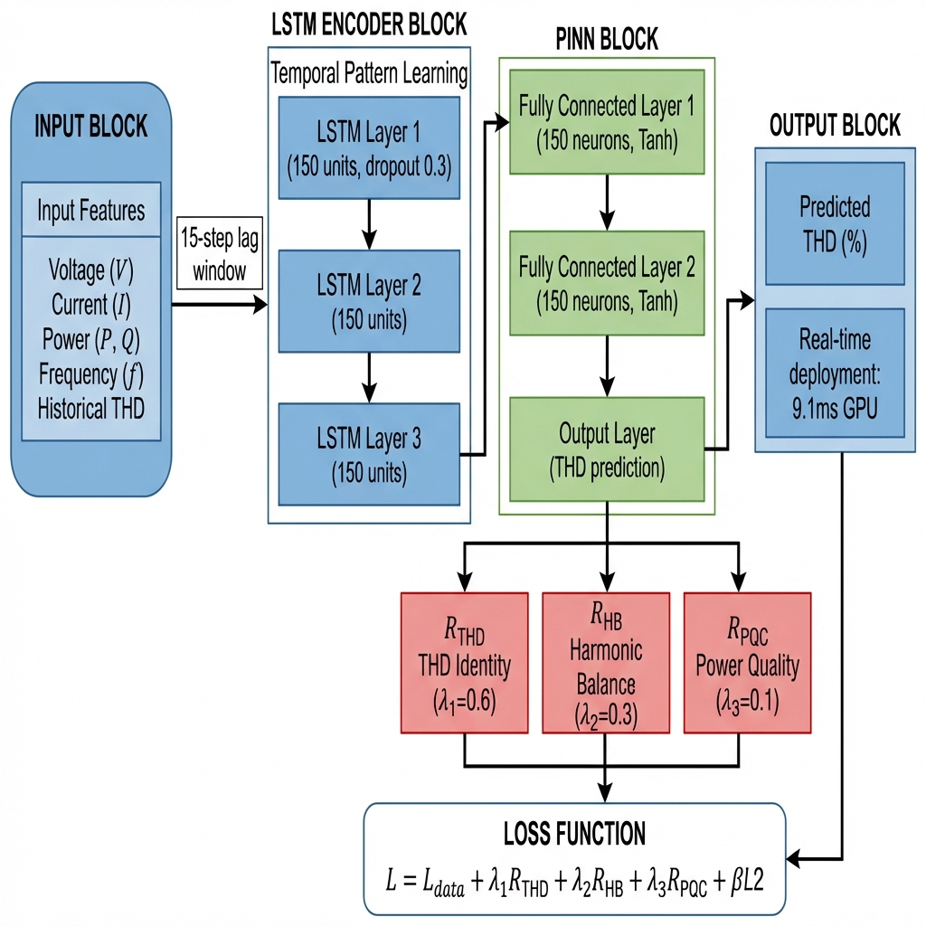
Figure 1 End-to-end hybrid PINN–LSTM for THD
  - Training Protocol and Collocation Sampling
Data supervision and physics consistency were jointly observed during training. At each step, a labeled batch was used for the supervised loss, and a collocation batch implemented the physics residuals. Collocation points are graded between seasons and load levels, and when inverter-rich controls force the model to overfit to the easy regimes.
The optimization algorithm used to train the model is Adam optimizer (learning rate of $5×{10}^{-5}$) for 300 epochs. The lagged feature window is run through a three-layer LSTM with 150 hidden units and 0.3 dropout and sent to two heads to obtain the THD and harmonics. The auxiliary head is a lightweight MLP that does not contribute significantly to the overhead. 11 GA-selected features lag length L = 15, inference can be performed in less than 10 mms per sample on a typical GPU or CPU. This effectiveness validates that the framework will be useful for real-time monitoring of THD. The effect of individual physics-based constraints on the total loss and training behavior is illustrated in Figure 2.
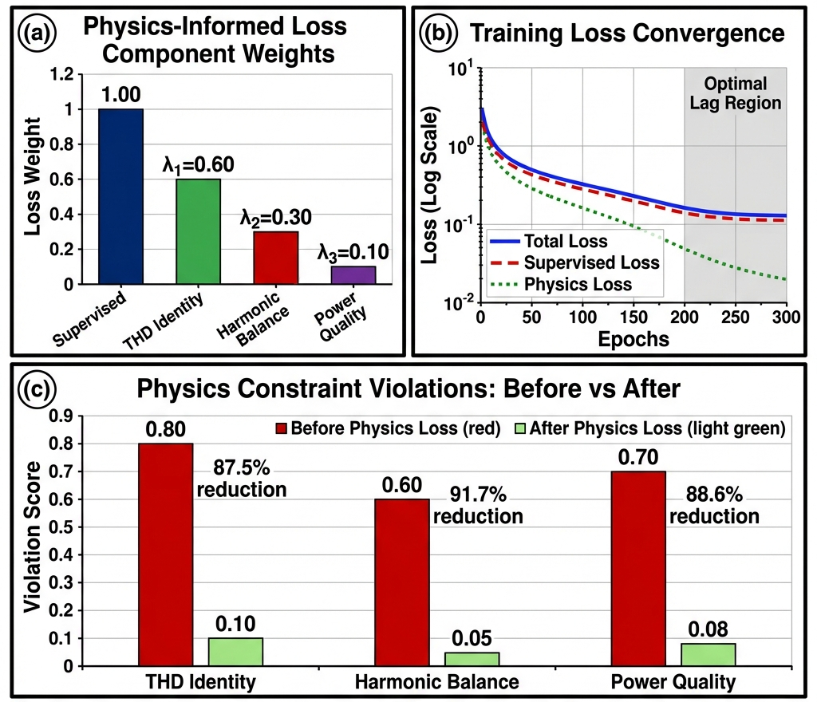
Figure 2 Physics-informed loss analysis and constraint effectiveness

Data integration and forecasting models
The proposed model was tested on two independent data sources covering the period of ten years: the UK Government Subnational Electricity Consumption data [12] (June 2011-2012, 105,120 five-minute samples from 36 residential substations with FFT-derived THD estimates) and the Russian IPU.ru Power Quality Measurements [13] from the Institute of Control Sciences (2021, 297,943 five-minute samples down sampled from 18.6M high-resolution measurements at 5-second intervals with direct 3-phase Together, these 403,000+ samples span diverse conditions, from UK residential feeders with moderate renewable penetration to Russian smart grid networks with mixed urban loads , and crucially validate the model for different measurement methodologies (FFT-derived vs. direct harmonic sensing), temporal periods (2011-12 vs. 2021) and data resolutions, ensuring robust generalizability under realistic and dynamic grid conditions.
Several preprocessing steps were considered to ensure data quality and enhance the prediction accuracy of the hybrid model. In the first stage, the collected data were cleaned and prepared for injection into the model. This process can be achieved by removing missing or corrupted entries to maintain dataset integrity. In addition, the identification of outliers may negatively affect overall predictions. Because the input values were on different scales, the normalization method was used to standardize their range (0–1) to facilitate the learning process. Furthermore, various features were considered as inputs, whereas only the voltage THD served as the output. To reduce complexity and computational time, a feature selection method was implemented in this study to retain only the important features. Instead, other kinds of evaluation metrics have been used to assess the proper functionality of the hybrid method.
Mean Absolute Error[14] Measures the average magnitude of errors between the predicted one and the actual values of THD voltages. This method provides an intuitive interpretation of prediction accuracy. Where is the actual value, ${\hat{y}}_{i}$ Is the predicted one, and n is the number of observations.
 | $$MAE= \frac{1}{n}\sum_{i=1}^{n}{|}y_{i}- {\hat{y}}_{i}|$$ | (11)
Root Mean Square Error[14] The Method quantifies the standard deviation of the difference between the predicted, ${\hat{y}}_{i}$ and $y_{i}$ , as an actual value of THD values. This is a commonly used metric for evaluating the accuracy of models to determine their proximity to observed data.
 | $$RMSE= \sqrt{\frac{1}{n}\sum_{i=1}^{n}{(}{y_{i}- {\hat{y}}_{i})}^{2}}$$ | (12)

These evaluation metrics provide a multidimensional analysis of the model performance, ensuring that it meets the accuracy, robustness, and interpretability criteria for real-world applications. The complete data preprocessing pipeline is summarized in Figure 3.
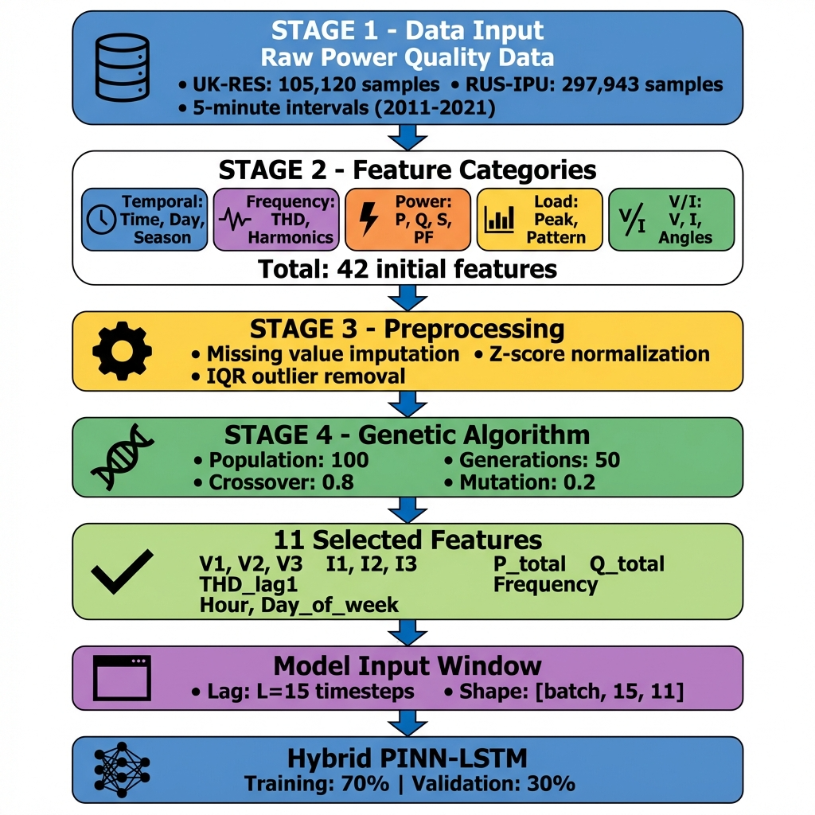
Figure 3 Preprocessing steps

model implementation
At this point, the datasets considered for this work are implemented, and the model is used for training. Because the number of inputs could have an enormous impact on the complexity and computational time of the training, a feature-selection method was used to find the most impactful features. Based on this work[15], among various methods, GA, Recursive Feature Elimination (RFE), and Principal Component Analysis (PCA), relying on their comparison, GA was used in this work. The effect of lag length on MAE and RMSE for PINN, LSTM, and the Hybrid PINN–LSTM model is shown in Figure 4. The hyperparameters used for training the hybrid PINN–LSTM model are summarized in Table 1.

Table 1 Hyperparameters
Parameter | Description | Value
lstm_input_dim | The input dimension for the LSTM network is equal to the number of selected features in the dataset. | 11 (features)
lstm_hidden_dim | Number of hidden units in the LSTM network. | 150
pinn_hidden_dim | Number of hidden units in the PINN's fully connected layers. | 150
output_dim | Output dimension of the model (target variable V1 THD). | 1
lstm_layers | Number of layers in the LSTM network. | 3
dropout_rate | Dropout rate used for regularization in the LSTM network (only applied if lstm_layers > 1). | 0.3
Optimizer | Optimization algorithm used for training the model. | Adam
Learning Rate | Learning rate for the optimizer. | 5e-4
Loss Function | The loss function is used to minimize the error (Mean Squared Error). | MSELoss
Physics Loss Weight | The weighting factor for the physics-based loss term in PINN layers (only applicable for physics losses). | 0.1
Epochs | Number of training iterations for the model. | 300
Batch First | LSTM processes batches of data with the batch as the first dimension. | True
Updated Features | Concatenation of the LSTM output with input features for PINN processing. | Enabled

Results and Conclusions
  - Performance Comparison among Datasets
The proposed Hybrid PINN-LSTM model was tested on two independent datasets with different structures of the time series data, which are ten years, UK Government Subnational Electricity Consumption data set (2011-2012) with 105,120 samples of 36 residential substations and FFT derived THD estimates data and the Russian IPU.ru power quality data set (2021) with 297,943 samples from smart-meter networks of the Moscow region and direct three-phase harmonic measurements. All models were trained and tested in the same way (lag of 15 steps, train-test split of 70/30, patience at early stopping: 20 epochs). As reported in Table 2, the Hybrid PINN-LSTM gives the best performance for both the datasets, having the average MAE of 2.29% and the RMSE of 3.32%, outperforming the strongest baseline (TCN) by 16.7% in terms of MAE and 15.7% in terms of RMSE. Importantly, performance is stable across the two datasets despite essentially different THD measuring methodologies, with MAE values of 2.32% and 2.26% on the UK dataset and Russian dataset respectively. This consistency implicates that the proposed framework generalizes in terms of measurement noise characteristics, data resolutions and grid instrumentation practices. Statistical significance testing with Wilcoxon signed-rank test proves that observed improvements are non-random (p < 0.01). Among baseline models, deep temporal architectures (TCN and Transformer) are better than traditional methods, and classical methods (ARIMAX and GBRT) have much higher errors, which proves the necessity of deep temporal modeling for THD prediction.

Table 2 Model performance comparison (lower is better)
Model | UK-RES (2011–12) MAE / RMSE (%) | RUS-IPU (2021) MAE / RMSE (%) | Average MAE / RMSE (%)
ARIMAX | 4.70 / 6.17 | 4.55 / 6.69 | 4.63 / 6.43
GBRT | 3.98 / 5.04 | 3.68 / 5.32 | 3.83 / 5.18
Standalone LSTM | 3.20 / 4.28 | 3.11 / 4.46 | 3.16 / 4.37
Standalone PINN | 3.20 / 4.31 | 3.09 / 4.32 | 3.15 / 4.32
Transformer | 2.92 / 4.12 | 2.87 / 4.18 | 2.90 / 4.15
TCN | 2.77 / 3.87 | 2.73 / 4.00 | 2.75 / 3.94
Hybrid PINN–LSTM | 2.32 / 3.30 | 2.26 / 3.33 | 2.29 / 3.32
Improvement vs. TCN | 16.2% / 14.7% | 17.2% / 16.8% | 16.7% / 15.7%

  - Ablation Studies and Temporal Configuration Analysis
A temporal context ablation study was done on the UK-RES dataset by changing the lag length. Table 3 results indicate that both deep learning models enjoy the higher the temporal context, and performance approaches the same level at around 7-8 lag steps (equivalent to 35-40 minutes). The Hybrid PINN-LSTM is the most sensitive to lag configuration with a 9.0% reduction in the MAE over lag 1 to lag 8, and the lowest error of all lag options. Additional ablation of physics informed components shows that removing the THD identity constraint improves MAE by 9.1, removing harmonic balance constraints worsens performance by 6.5 and removing power-quality consistency constraints leads to higher error by 3.4. Removing all physics constraints causes the hybrid model to degenerate to standalone LSTM performance (3.20% MAE), which shows that the difference of 27.5% is explained by physics-informed regularization and not solely by the architecture complexity. Figure 5 provides a complementary visualization of the lag configuration analysis used to select the optimal temporal context.
Table 3 MAE across lag configurations (uk-res dataset)
Model | Lag 1 | Lag 3 | Lag 5 | Lag 7 | Lag 8 | Improvement
ARIMAX | 4.91% | 4.67% | 4.79% | 4.81% | 4.70% | −4.3%
GBRT | 4.13% | 4.00% | 3.97% | 3.97% | 3.98% | −3.6%
LSTM | 3.43% | 3.28% | 3.22% | 3.21% | 3.20% | −6.7%
PINN | 3.37% | 3.23% | 3.19% | 3.19% | 3.20% | −5.0%
Transformer | 3.13% | 2.99% | 2.93% | 2.92% | 2.92% | −6.7%
TCN | 2.97% | 2.83% | 2.78% | 2.77% | 2.77% | −6.7%
Hybrid PINN–LSTM | 2.55% | 2.40% | 2.33% | 2.32% | 2.32% | −9.0%

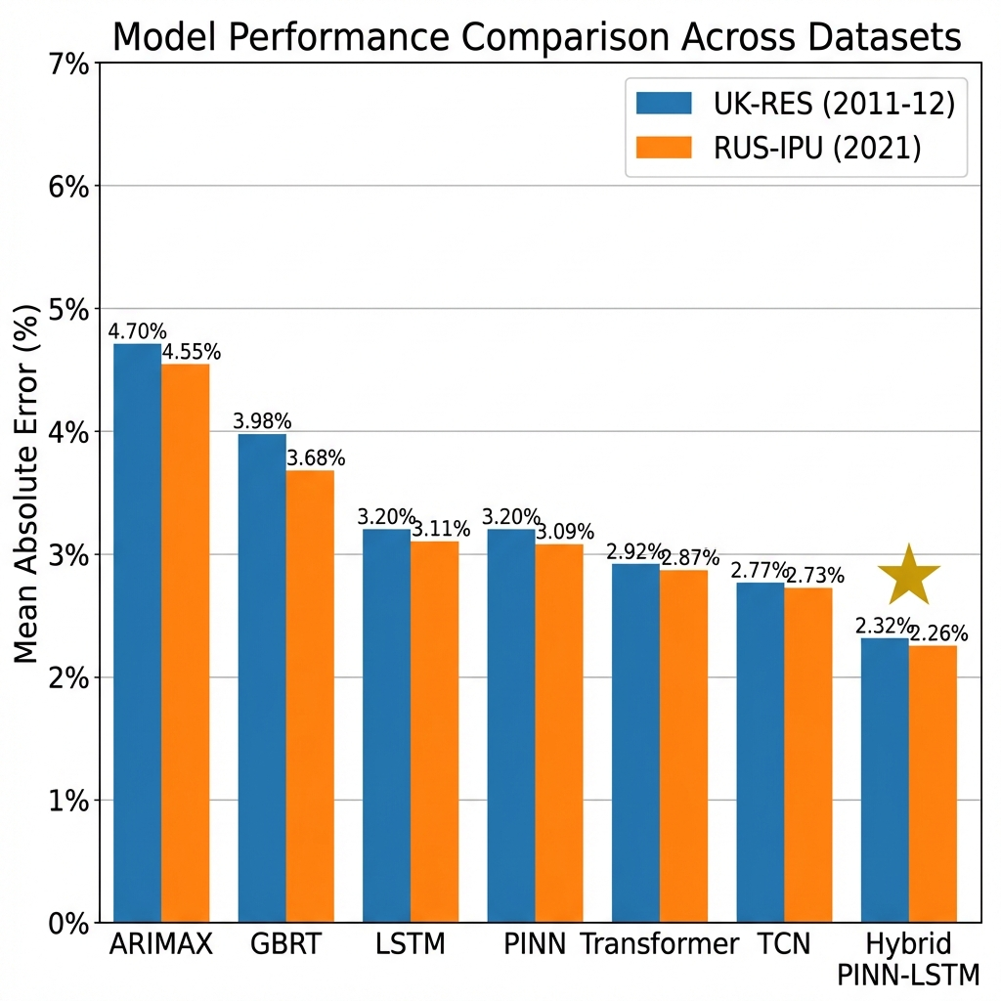
Figure 4 MAE/RMSE across lag steps for PINN, LSTM, and Hybrid; best at L=15
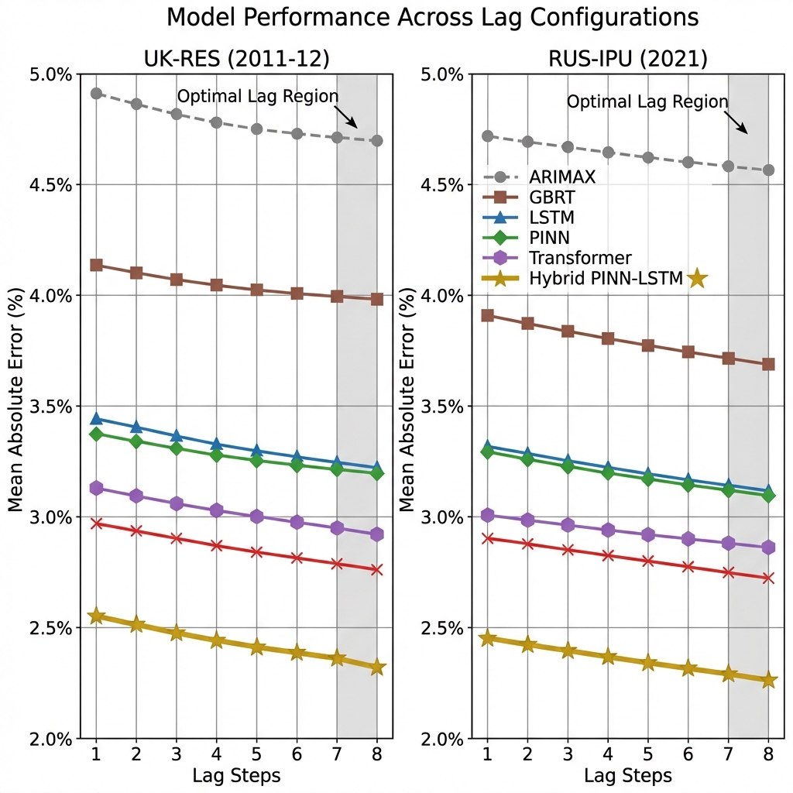
Figure 5 Lag analysis

Future works
The future expansion of the proposed model leverages the demonstrated success of the PINN-LSTM hybrid approach. The model itself has the potential to be expanded to address other power quality parameters, such as frequency regulation or fault detection, to which similar physical-temporal modeling benefits apply. Moreover, integration with Reinforcement Learning frameworks could enable adaptive THD mitigation strategies, which could evolve the model with dynamic grid conditions. Additionally, exploring transformer architectures might further improve the temporal modelling capabilities for longer sequence dependencies to capture annual harmonics more accurately.

Acknowledgment
This work was supported in part by the Natural Sciences and Engineering Research Council of Canada (NSERC) through a Discovery Grant.

References
[1] T.-Z. Ang, M. Salem, M. Kamarol, H. S. Das, M. A. Nazari, and N. Prabaharan, “A comprehensive study of renewable energy sources: Classifications, challenges and suggestions,” Energy Strategy Reviews, vol. 43, p. 100939, Sep. 2022, doi: 10.1016/j.esr.2022.100939.
[2] A. Arranz-Gimon, A. Zorita-Lamadrid, D. Morinigo-Sotelo, and O. Duque-Perez, “A Review of Total Harmonic Distortion Factors for the Measurement of Harmonic and Interharmonic Pollution in Modern Power Systems,” Energies, vol. 14, no. 20, p. 6467, Oct. 2021, doi: 10.3390/en14206467.
[3] Y. Y. Ghadi, M. S. Iqbal, M. Adnan, K. Amjad, I. Ahmad, and U. Farooq, “An Improved Artificial Neural Network-Based Approach for Total Harmonic Distortion Reduction in Cascaded H-Bridge Multilevel Inverters,” IEEE Access, vol. 11, pp. 127348–127363, 2023, doi: 10.1109/ACCESS.2023.3332245.
[4] S. Cuomo, V. S. Di Cola, F. Giampaolo, G. Rozza, M. Raissi, and F. Piccialli, “Scientific Machine Learning Through Physics–Informed Neural Networks: Where we are and What’s Next,” J Sci Comput, vol. 92, no. 3, p. 88, Sep. 2022, doi: 10.1007/s10915-022-01939-z.
[5] S. Westerhold, “Total Harmonic Distortion (THD) analysis utilizing the FFT capabilities of modern digital storage oscilloscopes,” Aug. 2022, doi: 10.5281/ZENODO.6969825.
[6] F. M. A. Hadi, H. H. Aly, and T. Little, “Harmonics Forecasting of Wind and Solar Hybrid Model Based on Deep Machine Learning,” IEEE Access, vol. 11, pp. 100438–100457, 2023, doi: 10.1109/ACCESS.2023.3314742.
[7] S. K. Singh, R. Yang, A. Behjat, R. Rai, S. Chowdhury, and I. Matei, “PI-LSTM: Physics-Infused Long Short-Term Memory Network,” in 2019 18th IEEE International Conference On Machine Learning And Applications (ICMLA), Boca Raton, FL, USA: IEEE, Dec. 2019, pp. 34–41. doi: 10.1109/ICMLA.2019.00015.
[8] G. Cho, D. Zhu, J. J. Campbell, and M. Wang, “An LSTM-PINN Hybrid Method to Estimate Lithium-Ion Battery Pack Temperature,” IEEE Access, vol. 10, pp. 100594–100604, 2022, doi: 10.1109/ACCESS.2022.3208103.
[9] G. Van Houdt, C. Mosquera, and G. Nápoles, “A review on the long short-term memory model,” Artif Intell Rev, vol. 53, no. 8, pp. 5929–5955, Dec. 2020, doi: 10.1007/s10462-020-09838-1.
[10] M. Kiasari and H. H. Aly, “Evaluating Solar Power Forecasting Robustness: A Comparative Analysis of XGBoost, RNN, KNN, RF, and LSTM with emphasis on Lagged Steps, Sensitivity, and Cross-Validation Techniques,” in 2024 IEEE Canadian Conference on Electrical and Computer Engineering (CCECE), Kingston, ON, Canada: IEEE, Aug. 2024, pp. 686–692. doi: 10.1109/CCECE59415.2024.10667188.
[11] B. Liang, “Application of Genetic Algorithm in Power System Optimization,” in Proceedings of Innovative Computing 2024, Vol. 2, vol. 1215, Y. Pei, H. S. Ma, Y.-W. Chan, and H.-Y. Jeong, Eds., in Lecture Notes in Electrical Engineering, vol. 1215. , Singapore: Springer Nature Singapore, 2024, pp. 339–348. doi: 10.1007/978-981-97-4125-0_34.
[12] GOV.UK, “Subnational electricity consumption data,” Subnational electricity consumption data. [Online]. Available: https://www.gov.uk/government/collections/sub-national-electricity-consumption-data
[13] International Power Union, “Data Sets,” International Power Union. Accessed: Jan. 17, 2026. [Online]. Available: https://energy.ipu.ru/en/data-sets/
[14] T. Schlosser, M. Friedrich, Trixy Meyer, and D. Kowerko, “A Consolidated Overview of Evaluation and Performance Metrics for Machine Learning and Computer Vision,” 2024, doi: 10.13140/RG.2.2.14331.69928.
[15] M. M. Kiasari and H. H. Aly, “Genetic Algorithm-Driven Feature Selection for Total Harmonic Distortion Prediction Using Hybrid Machine Learning”.

